P4.1 Mastery Quiz: Matter
Section A

- In which state of matter do particles have the greatest internal energy? [1]
Tick ( ) one box.
- Solid | 
- Liquid
- Gas

- Which state(s) of matter can be compressed? [1]
Tick ( ) one box.
- Only solids
- Liquids and gases
- Only gases

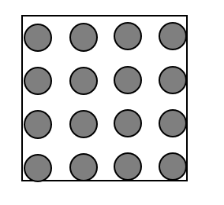
- The diagram shows a particle diagram that a student has drawn to represent the particles in a gas.

Which explains a problem with the student’s diagram?

Tick ( ) one box.
- The particles in a gas are randomly arranged rather than in a regular pattern
- Gases do not contain many particles, so there should be fewer circles
- The particles of a gas should be drawn as white circles

- Gas pressure is caused… [1]
Tick ( ) one box.
- by collisions of particles with each other.
- by collisions of particles with the walls of a container.
- only when particles in a gas are moving.

- Which statement is correct about energy of particles when substances are heated? [1]
Tick ( ) one box.
- Kinetic energy always increases
- Potential energy always increases
- Internal energy always increases

- A student wanted to determine the density of an irregularly shaped piece of rock.

The method they used is shown below.

      - Fill a measuring cylinder with water
      - Add the rock to the cylinder
      - Measure the volume of water on the cylinder
      - Use this volume and the mass to calculate density.

Choose why this method will not allow density to be determined. [1]
Tick ( ) one box.
- A beaker should be used to more accurately measure volume
- The measuring cylinder should not be filled because water will spill out
- The length, width and height of the rock must be measured

- Select the unit that could be used to describe density.
Tick ( ) one box.
- m³/kg
- kg m³
- m/kg
- kg/m³

- The cubes below all have the same mass.

C
B
A

Which of the cubes has the highest density?
Tick ( ) one box.
- A
- All cubes have the same density
- C

- There is 1 kg of oxygen in a sealed container.

The temperature of the oxygen is increased from 18 ⁰C to 100 ⁰C.

Choose the best description of the effect of the temperature change. [1]
Tick ( ) one box.
- Oxygen becomes a gas at the boiling point of 100 ⁰C
- Particles of oxygen move more quickly causing a higher pressure
- Particles of oxygen have a lower thermal energy as the temperature has increased

Physics Only

- Choose where atmospheric pressure is greatest. [1]
Tick ( ) one box.
- 1 m above sea level
- 200 m above sea level
- Atmospheric pressure is the same at different heights.

- 2 m³ of a gas had a pressure of 50 Pa.

The gas was compressed, and the final pressure was 400 Pa.

Calculate the volume of the compressed gas. [1]

Tick ( ) one box.
- 4 m³
- 100 m³
- 0.25 m³

Higher tier only

- The deeper a fish swims in water, the greater the pressure becomes because … [1]
Tick ( ) one box.
- water is more dense near the surface.
- the fish weighs more the deeper it goes.
- there is a greater weight of water above the fish.

- There is 20 kg of nitrogen in a sealed container.

The temperature is constant.

When the volume increases, the pressure … [1]
Tick ( ) one box.
- increases.
- decreases.
- stays the same.

- In a column of liquid, the pressure is greatest at the deepest point because… [1]
Tick ( ) one box.
- there are more particles exerting a downwards force.
- there is more gravity the greater the height.
- the density is greater.

- A toy boat floats on the water in a bath.

The water exerts a greater pressure on the bottom of the toy boat than the top surface which causes… [1]
Tick ( ) one box.
- a resultant force downwards.
- upthrust.
- sinking.

- A marble is released into a 5 m tall column filled with water.

Calculate the pressure on the marble when it is half way down the column.

The density of water is 998.2 kg/m³.

The gravitational field strength on Earth is 10 N/kg.

Below shows how to calculate the pressure due to a column of liquid:

pressure due to a column of liquid = height of column × density of liquid x gravitational field strength

[1]
Tick ( ) one box.
- 25 kPa
- 40 kPa
- 50 kPa

Section B

- A student measured the volume and mass of a material. The results are shown below.

Mass = 18 g
Volume = 45 cm³

Calculate the density of this material. Include units. [3]
_________________________________________________________________________________
_________________________________________________________________________________

- Describe a method that could be used to determine the density of this toy. [6]
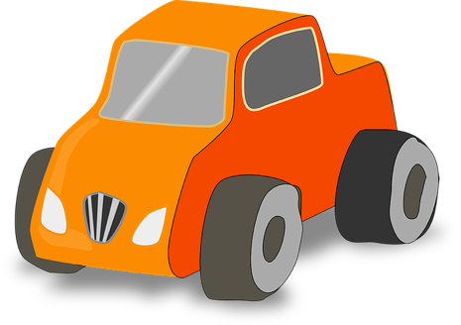

_________________________________________________________________________________
_________________________________________________________________________________
_________________________________________________________________________________
_________________________________________________________________________________
_________________________________________________________________________________
_________________________________________________________________________________
_________________________________________________________________________________
_________________________________________________________________________________

- Compare the arrangement of particles in solids and liquids. [4]
_________________________________________________________________________________
_________________________________________________________________________________
_________________________________________________________________________________
_________________________________________________________________________________

Physics only

- A pump is used to inflate a car tyre as shown in the photo below.
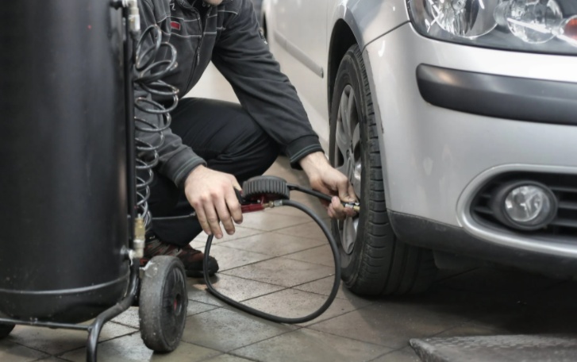
Image source – Andrea Piacquaido/Pexels

Explain why the internal energy of the air increases as the tyre is inflated. [4]
_________________________________________________________________________________
_________________________________________________________________________________
_________________________________________________________________________________
_________________________________________________________________________________

